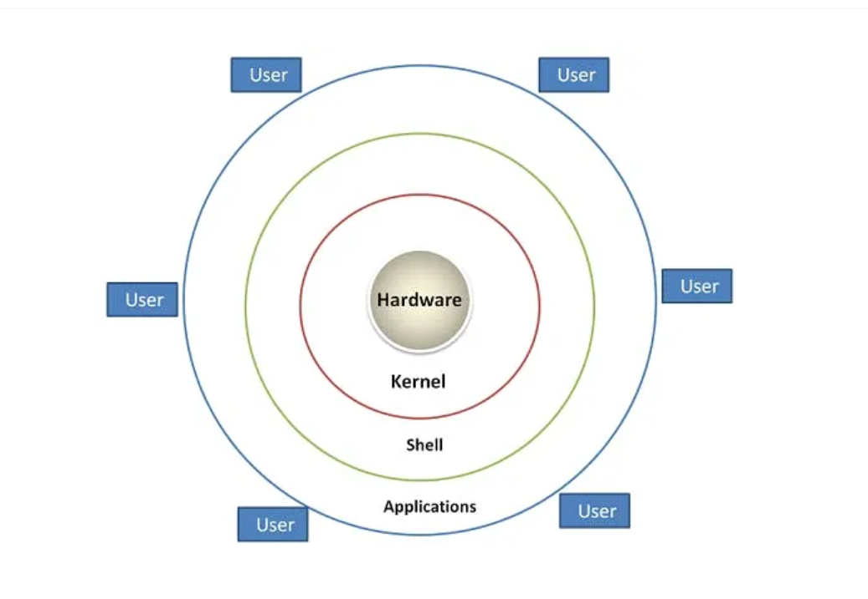

1. Hardware
The lowest level of the Linux architecture is the hardware layer. This layer comprises the physical components of a computer, such as the hard drive, RAM, motherboard, CPU, network interfaces, and peripherals. These components are the tangible pieces of your system on which the rest of the architecture is built.

2. Kernel
Directly interfacing with the hardware layer is the kernel, the heart of the Linux operating system. As the core part of the OS, the kernel is responsible for low-level tasks such as disk management, task scheduling, memory management, and controlling peripherals.
The Linux kernel is a monolithic kernel, meaning it encompasses device drivers, file systems, system server calls, and more, all in a single static binary file. Because the kernel directly interacts with the system’s hardware, it’s crucial in terms of system performance and stability.
3. Shell
One layer up from the kernel is the shell. In simplest terms, the shell is a user interface that allows users to interact with the kernel. In Linux, most interactions with the shell occur in a command-line interface (CLI), where users type commands interpreted by the shell.
There are several different shells available in Linux, each with its unique features and syntax, such as the Bourne Again Shell (bash), the C Shell (csh), and the Z Shell (zsh).
4. Applications
The topmost layer of the Linux architecture consists of applications. These are the software programs that you, as the user, interact with directly. They range from system applications like file managers, text editors, and network managers, to user applications like browsers.
While applications communicate with the hardware through the kernel, they interact with the user through the shell. For instance, when you run a command to open a file in a text editor, the shell interprets your command, the kernel fetches the file from the hardware, and the text editor (application) displays it.
